Nicky Lin

Professor Stetler

BIOL-1015-03

03/29/23

Lab 9 Word Doc

Figure 1. shows a comparison of crustacean density between Lake Big Moose and Lake G. The annual average of crustaceans in Lake G is higher than that in Lake Big Moose.

**8  Data Analysis and Results**

AHP under the fuzzy environment has been used in this work for greater accuracy and efficiency. To determine the overall idealness and performance nature of the different sources of big data breaches in healthcare sectors, five above-mentioned sources of healthcare data breaches as attributes have been considered for this experiment. These attributes are symbolized as PRC Big Database (D1), HIPAA Journal (D2), OCR Reports (D3), Ponemon Institute Reports (D4), and Verizon-DBIR (D5) in the following tables. From 2010 to present year, the data analysis of these sources of big data breaches related to healthcare sectors and others are explained. With the help of [[25](https://www.techscience.com/iasc/v32n3/45931/html#ref-25)–[29](https://www.techscience.com/iasc/v32n3/45931/html#ref-29)], assessment of the supervised and the unsupervised approaches under fuzzy-based AHP environment has been examined as follows and [Tab. 8](https://www.techscience.com/iasc/v32n3/45931/html#table-8) demonstrates fuzzy pair-wise comparison matrix based on collected expert’s judgment.

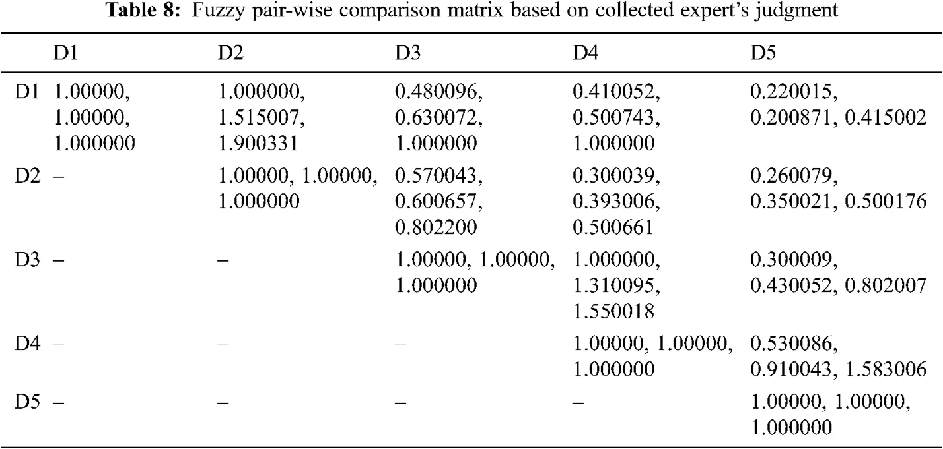

Defuzzification is used after the comparison matrix is built to generate a measurable value based on the derived TFN values. The defuzzification approach used in this study was developed from [[35](https://www.techscience.com/iasc/v32n3/45931/html#ref-35),[44](https://www.techscience.com/iasc/v32n3/45931/html#ref-44)–[45](https://www.techscience.com/iasc/v32n3/45931/html#ref-45)], which is often referred to as the alpha cut method, as defined in [[30](https://www.techscience.com/iasc/v32n3/45931/html#ref-30)–[33](https://www.techscience.com/iasc/v32n3/45931/html#ref-33)]. The set of all items in a fuzzy set is called the alpha cut. Any number between 0 and 1 is used as the alpha threshold value. As a result, the alpha threshold value of 0.5 was chosen. Which have a membership value that is more than or equal to an alpha threshold value, denoted by α. A fuzzy set may be described as a collection of crisp sets using the alpha cut technique. Crisp sets simply state whether or not an element belongs to the set. The alpha cut method is depicted in [[34](https://www.techscience.com/iasc/v32n3/45931/html#ref-34)–[37](https://www.techscience.com/iasc/v32n3/45931/html#ref-37)]. [Tab. 9](https://www.techscience.com/iasc/v32n3/45931/html#table-9) shows the defuzzified final fuzzy pair wise comparison matrix.

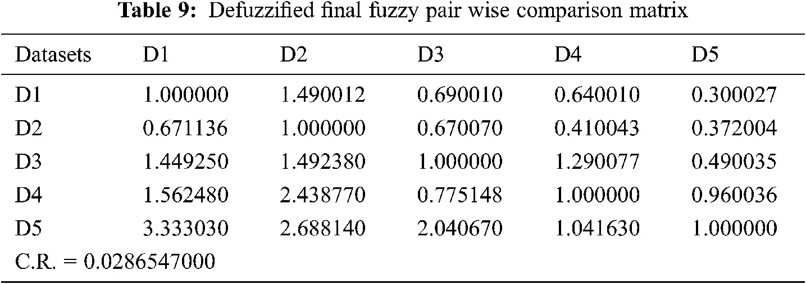

[Tab. 9](https://www.techscience.com/iasc/v32n3/45931/html#table-9) shows the normalised values and defuzzified local weights of characteristics. The weights and priority of the characteristics have been established with the assistance of the local attribute-weights. [Tab. 10](https://www.techscience.com/iasc/v32n3/45931/html#table-10) shows the results.

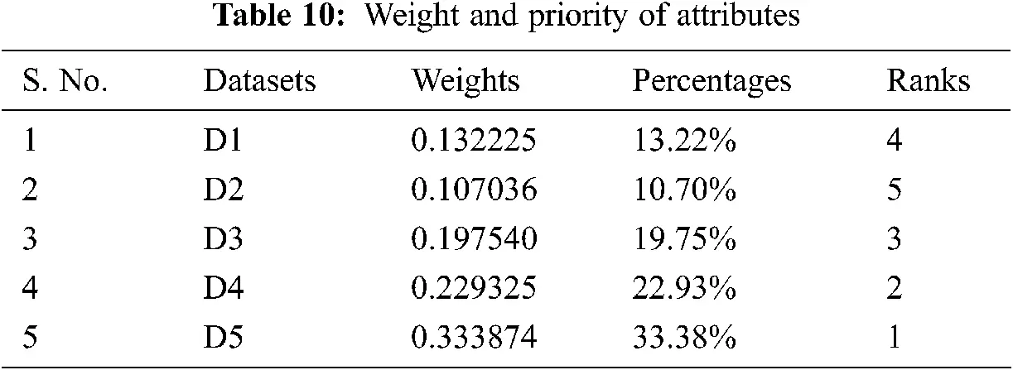

The most important task for every researcher [[36](https://www.techscience.com/iasc/v32n3/45931/html#ref-36)] is to validate the evaluated outcomes. The authors to this study compared the results to those of another comparable approach called the traditional Fuzzy-AHP in order to accomplish validation and offer a clear perspective of the acquired outcomes. The authors calculated the same data using the traditional Fuzzy-AHP approach with the same data. [Tab. 11](https://www.techscience.com/iasc/v32n3/45931/html#table-11) and [Fig. 5](https://www.techscience.com/iasc/v32n3/45931/html#fig-5) show the outcomes of both methods. The findings of both approaches are strongly linked (person correlation coefficient is) [[44](https://www.techscience.com/iasc/v32n3/45931/html#ref-44)–[45](https://www.techscience.com/iasc/v32n3/45931/html#ref-45)], as shown in [Tab. 11](https://www.techscience.com/iasc/v32n3/45931/html#table-11). Further, [Tab. 11](https://www.techscience.com/iasc/v32n3/45931/html#table-11) shows that the fuzzy-based technique outperforms the classical methodology.

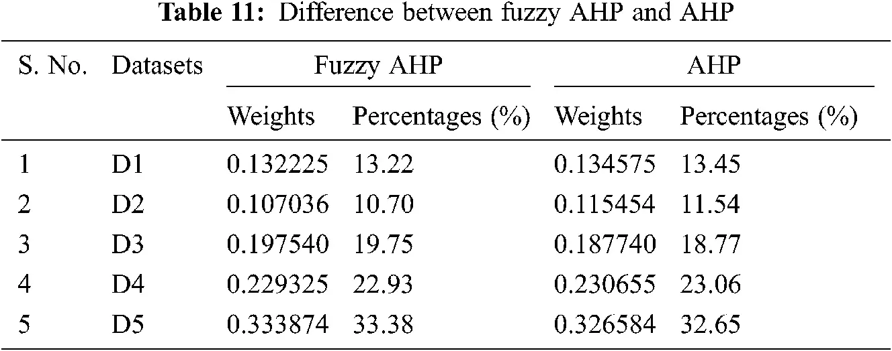

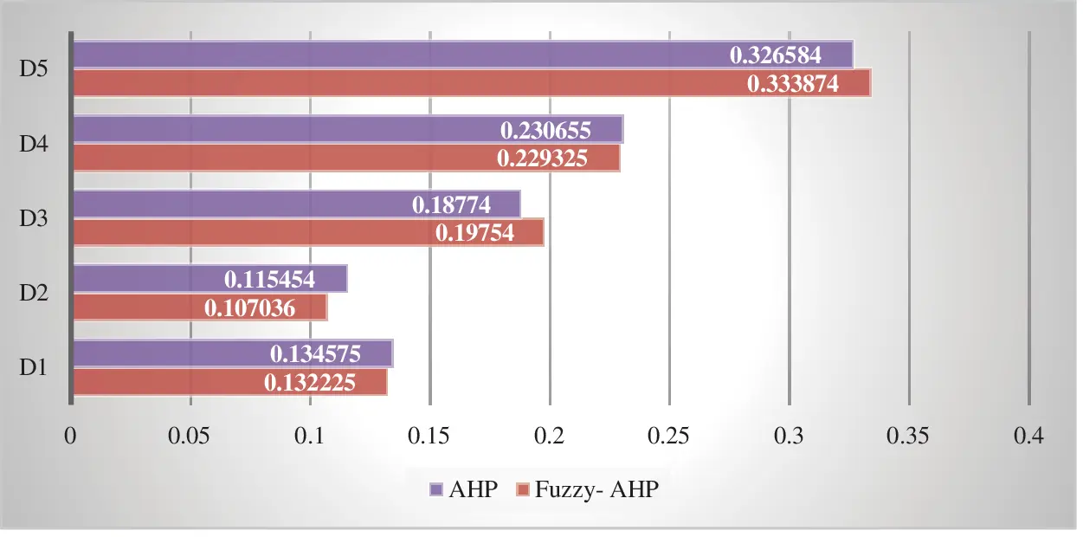

**Figure 5:** Comparison between the results through fuzzy AHP and classical AHP

[Fig. 5](https://www.techscience.com/iasc/v32n3/45931/html#fig-5) shows the graphical representation of the comparison between the results obtained from the Fuzzy AHP and Classical AHP including global weights and priority of the attributes in healthcare big data breaches. It can be clearly seen that Fuzzy-AHP is more efficient than Classical AHP.

References

Almulihi, A. H., Alassery, F., Khan, A. I., Shukla, S., Gupta, B. K., & Kumar, R. (2022). Analyzing the Implications of Healthcare Data Breaches through Computational Technique. Intelligent Automation & Soft Computing, 32(3), 1763–1779. <https://doi.org/10.32604/iasc.2022.023460>